**ANDROID IOIO HEALTH MONITOR**

**Adam Fobbe**

**Bader Alqahtani**

**Ryan Benzschawel**

**Jessica Dahlquist**

**Saksham Ghimire**

**CEE-405 CAPSTONE DESIGN I**

**<Fall> <2013>**

**University of Wisconsin - Stout**

**Engineering and Technology Department**

**Computer Engineering Program**

**University of Wisconsin -Stout**

**TABLE OF CONTENTS**

ABSTRACT 3

ACKNOWLEDGEMENTS 3

1. INTRODUCTION 4

2. PROBLEM STATEMENT5

2.1 General Design Approach 5

2.2 Specifications 7

2.3 Project Schedule 9

3. DESIGN CHOICES AND PERFORMANCE CRITERIA 10

4. DETAILS OF DESIGN 11

4. 1 Final Design Details 11

4.2 Design Tasks for Each Member 13

4.3 Test Results and Conclusions 14

4.4 Final System Considerations 16

5. CONCLUSIONS AND SUMMARY 16

6. REFERENCES 16

7. APPENDICES 17

7.1 Bill of Materials (BOM) 17

7.2 System Cost Summary 17

7.3 Data Sheets and Vendor Specifications 18

7.4 Physical Description of Product 35

7.5 Testing 36

7.6 Calculations 37

**ABSTRACT**

To develop a portable health monitor for asthma patients that will measure air quality using current medical devices that will communicate to an Android device via Bluetooth. The device includes temperature, humidity, dust, CO2, ozone, and GPS sensors.

**ACKNOWLEDGEMENTS**

We would like to mention those who have helped or assisted us in our educational journey and specifically with this final senior project. First, we would like to thank God for the abilities and talents that are bestowed upon us all. Also, we would like to thank the professors at UًW-Stout who have helped us learn a great deal in our engineering path through instruction, examples and taking the time to encourage the students. We also want to thank our friends and family who have been supportive through thick and thin in many ways.

We will not tell a lie. This class has been very challenging, but it has also been one of the most rewarding classes of our college career as well. Dr. Liu has been an inspiration to us and the others throughout the semester. Also, we would like to tip our hat to Dr. Turkmen, Dr. Nelson and Dr. Bae who really helped us with their recommendations and suggestions. To get through this final checkpoint, it took the support of many people, our parents, our professors, our classmates and the friends in our life. And of course we would like to thank god for endowing us with the strength we needed to get through this final semester.

To Dr. Liu, personally, you played such an instrumental role in our development at UW-Stout through your mentorship and through many of our conversations. There is no way that we could ever comprehend our gratitude for you and your excellent and well-taught class.

How do we truly begin to thank this great institution of UW-Stout? There are so many departments and people that took a personal interest in our development. We would like to acknowledge the various professors throughout the engineering department whom we spoke to often. We would like to thank our fellow classmates for their unyielding support that really made us think smarter and harder about engineering.

Throughout our career at UW-Stout, there has always been a mentor for every individual of our team who knows what we think and why. It is that intuitive nature, community, and dream building that makes UW-Stout so great and us to be proud to soon be alumni of this great place.

**1. INTRODUCTION**

The medical device industry in today’s world plays a significant role in improving lives of patients. From revolutionary pacemakers to state of the art diagnostic devices, the healthcare industry has been adopting new technologies to treat patients and help them take better care of themselves. The National Science Foundation (NSF) has been an active organization to help researchers bring new technologies to the market and help healthcare organizations recommend these products to patients.

Most of today’s medical devices have been credited for being proactive in the development of health care facilities both in terms of planning and building of new treatment centers and upgrading and improvement of existing facilities. This also depends on the type of health problem being treated since some medical devices are dedicated to help improve specific health problems. According to World Health Organization (WHO), “Medical devices are indispensable for effective prevention, diagnosis, treatment and rehabilitation of illness and disease”.

Although, the medical device industry has been able to cover most of the common worldwide health problems, there are still a few health problems that require immediate attention of the medical device industry to help patients become proactive and be able to monitor their health in real time. The NSF has been actively involved in helping researchers develop innovative ways of helping Asthma patients. The patients diagnosed with asthma have to be extremely careful about the environment conditions they are trying to adapt in. Factors such as temperature, humidity, amount of smoke, CO2, NO2 and ozone present in the atmosphere can trigger asthma related attacks. The patient has to be aware of the existing atmospheric conditions and avoid any conditions that might pose a threat towards their health condition. By far, no medical device companies have come up with a concrete solution to help the asthma patients monitor the environment in real time.

By applying concepts from computer and electrical engineering, we as engineers are professionally obligated to help solve this problem for asthma patients. The need for a medical device that can constantly monitor atmospheric conditions and instantly notify asthma patients must be fulfilled to resolve the problem.

**2. PROBLEM STATEMENT AND SPECIFICATIONS**

We have a need to research and develop a medical device to help asthma patients constantly monitor atmospheric conditions and get real time updates about the condition.

The device must be able to sense and consider all relevant atmospheric factors and process them with high precision and accuracy. The device must be portable and should communicate wirelessly with the patient’s smart phone to synchronize information from the device. The health monitor device must also be able to store patients data securely which can later be retrieved by an authorized personnel. The device must follow FDA regulations in the United States and must be able to pass health regulations in other countries internationally.

The specifications for this project are as follows:

1. Communicate to an android device via Bluetooth
2. Get atmospheric condition updates using sensors such as GPS, temperature, dust, humidity, CO2, NO2, and ozone.
3. Design an ergonomic enclosure
4. Supply power using a rechargeable battery
5. Interface a storage unit for sensor data
6. Warn users of high exposure levels

**2.1 General Design Approach**

From initial research, it was clear that there are a few devices in the market that are commercially available and are able to read various atmospheric conditions. They were inexpensive and simple to use. Considering the cost and the simplicity of these existing products, they did have some drawbacks. These products are designed to measure only a specific factor that contributes towards air quality. To measure all factors that come into play when air quality has to be tested, all the devices would have to be separately. This would add up on the cost of the device and would not be portable at all. Since, these devices are built for specific purposes, it would not be feasible to have them all work together without avoiding compatibility issues and other technical difficulties.

To serve the purpose of this project to the fullest, a device was needed that met all the specifications and is specifically customized to help asthma patients. Since, there were no devices out on the market that are specifically designed to help asthma patients and met the project specifications, the group’s decision was to build one and fully customize it to help asthma patients.

The first and foremost challenge for the group was choosing a single-board microcontroller that is able to connect to an android device using Bluetooth and had extensive support for the android operating system. The group was interested in Arduino Mega ADK board because of its native android support. Arduino boards have been very popular among electronics tinkerers and engineers. The simplicity of Arduino architecture in terms of both hardware and software facilitates developing projects faster and easier. However, this particular board was fairly new in the market and not very popular among android developers. The libraries released by the developers were very limited when it came to the Arduino Mega ADK. Taking into account, the seriousness of this project, the group decided to move on to the next microcontroller lacking confidence about building a medical device based on this board.

The second board that was taken into account was the IOIO mint board. It also had native support for the android operating system. The libraries that were needed were already made available by the developers and this board basically included everything the project demanded. It was enclosed in a small tin box and the group was intrigued by the idea of assembling all the sensors inside the IOIO box. By assembling all the electronic components in the box, it would make the device small and easily portable. However, as soon as the sensors we brought in, the group realized that this board would be too small to fit all the components in. Since, the project specification also required an ergonomic enclosure; a decision was made to find a board similar to IOIO mint, design custom enclosure and prototype using a 3D printer.

The third board that was taken into consideration was “IOIO for Android”. It is very similar to the IOIO mint board in terms of functionality. The only difference is that “IOIO for Android” does not ship with a pre-built enclosure and lacks header pins. This allowed easy soldering around the pins and also provided more flexibility to add in a new layer of Printed Circuit Board (PCB) to directly solder sensors and the breakout boards. The team finalized “IOIO for Android” as the board on which the device will be based on. Since it already had analog inputs, interfacing additional sensors would be a simple task.

The temperature and humidity sensors were very straight forward and the group had no issues setting them up. Meanwhile, android code was developed that would help any android device communicate with the device. The GPS and dust sensors were tricky and required more troubleshooting. A voltage divider was used to control the voltage driving into the NO2 and Ozone sensors. The Bluetooth 2.0 dongle we used worked seamlessly to connect the board with an Android smartphone. Also, a memory card circuit was interfaced for future implementation of a memory card to store sensor data.

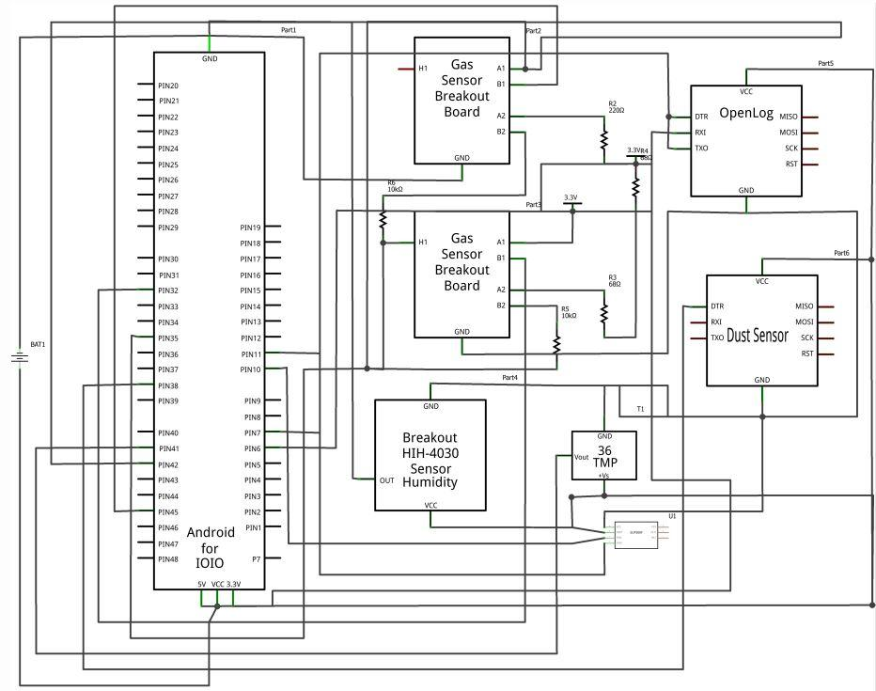

Fig: Project Schematics

**2.2 Specifications**

The success of the project hugely depends on the preliminary requirements stated in the project definition. Since, this is a medical device, extra layers of safety and precaution have to be taken into account to prevent any accidental damage. The patient will be carrying the device in a very close proximity which increases the safety factors related to the device. The technical specifications are as follows:

1. The device must be able to communicate to an android device via Bluetooth
2. The device must be able to measure air quality using sensors such as GPS, temperature, humidity, dust, CO2, NO2, and ozone.
3. The device must be enclosed inside a safe and ergonomic enclosure
4. The device must be able to run using a rechargeable battery
5. The device must be able to store patients data using latest flash memory storage technology
6. The device must regularly and seamlessly work with the software on the patient’s phone and warn them of high exposure levels.
7. The device must have a fallback plan such as a reset option in cases of malfunction
8. The device must be lightweight to carry and must be comfortable to carry around for longer periods of time
9. The device must use low power to keep the battery from draining out quickly
10. The device must be reasonably affordable

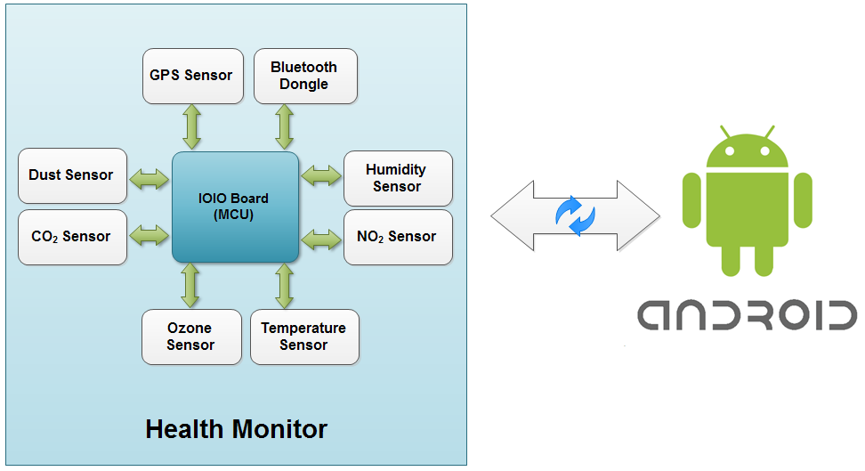

Fig: Block diagram showing the interaction of sensors with the IOIO board

The implementation of wireless technology in medical devices has many benefits such as patient mobility and to avoid being on the bed for longer periods of time. Also, wireless medical devices can be remotely programmed and physicians are able to access patient data from anywhere. By allowing remote monitoring physicians are able to help more number of patients in real time. Also the patient would benefit from wireless medical devices because of its portability. As engineers, who have taken the task of building a medical device to help asthma patients we need to be extremely careful about what kind of wireless technology we are implementing, the kind of risks we are taking in case of any accidental damage, data security and most importantly, the Electromagnetic Compatibility (EMC).

In cases of electronic medical devices, the Federal Communications Commission (FCC) and the Food and Drug Administration (FDA) work together to insure the quality of electronic devices. The FCC also oversees the use of Radio Frequency (RF) within which various RF wireless technologies operate. For this project, the only wireless technology we have used is the Bluetooth chip to connect the health monitor to an android phone. According to the FCC, any Bluetooth enabled device must be a short range broadcast equipment operating between 2.4 to 2.485 GHz, using a spread spectrum, frequency hopping, full-duplex signal at a nominal rate of 1600 hops/sec. The 2.4 GHz ISM band is available and unlicensed in most countries. The FDA along with the FCC also requires that the authorized personnel for prescription of medical devices using wireless radio frequency are obligated to notify/warn customers about incorporated radio frequency. The FCC also has a list of exceptional conditions which allows certain unintentional radiators. They are codified in 47 CFR 15.103 and are exactly as follows:

* *Digital devices oscillating below 1.705 MHz that do not connect to the power grid, even indirectly,*
* *To be exempt, devices also cannot connect for the purpose of recharging batteries.*
* *Digital devices that use less than 6 billionths of a watt (6 nW) of electrical power*
* *Devices only used in vehicles*
* *Specialized medical, electrical utility or commercial test & measurement devices.*
* *Appliances (white goods), or devices used exclusively in appliances.*
* *Non-digital simple passive devices*

**2.3 Project Schedule**

To keep the project on schedule a Gantt chart was used. The chart divided all tasks to members of the group and gave deadlines. The first part of the schedule designated a lot of time for research. The group worked on researching IOIO boards and sensors then it designated different tasks to each team member. Jessica worked on product concept designs while Bader worked researched enclosure designs. Adam and Saksham researched different storage devices for the data collected from the device whereas Ryan researched the battery and charger. The parts were ordered the third week in October to ensure their delivery in time to finish the project. The project was delayed for a while because the sensors were on backorder and additional research was needed to order sensors that were in stock.

The other tasks were writing code for the sensors which Adam and Saksham worked together on. Everyone in the group worked together to install the sensors and to get them operational. The group also worked on testing and troubleshooting the device to get it operational. The attached Gantt chart will give more specific details pertaining to the project schedule. There were no major changes to the Gantt chart except we added a deadline for prototype one. This was added because most projects will require more than one prototype and having a deadline for one earlier made the timeline more feasible.

**3. DESIGN CHOICES AND PERFORMANCE CRITERIA**

There were many design choices involved in this project. One consideration was which IO board to choose. There are many boards on the market but some considerations that were taken were size, cost, communication ports, supply voltage and input/output connections.

The first board we looked at was the Arduino Mega ADK board. This board could do everything that we wanted it to and had many input/output pins to use. The main downside to this board though was that it was just too large for us to use in an enclosure. The second board that we looked at was the IOIO Mint board. This board was small and came in a very nice enclosure. It had fewer pins but would still work for our needs. The third and final board we decided to use was the IOIO for Android board. This board had a very simple design and was easy to get started with. It is also the smallest in size out of the boards we had previously looked at so that played a large part in our choice.

One more design consideration was what type of battery to use because this device was going to be portable. The IO board that was chosen needed 5VDC to operate so a battery greater than 5 volts was needed. A polymer lithium ion battery (LiPo) was chosen because of the small size and high mA storage. A single cell LiPo battery only outputs 3.7VDC so a two cell battery was chosen that outputs 7.4VDC and has 1000 mAh of charge. One inconvenience with a LiPo battery is that a special charger is needed. This LiPo battery charger added cost to the project that was unexpected.

Another consideration for the project was what type of sensors to order. We used several different sensors in this device including a temperature sensor, a humidity sensor, an Ozone (O3), a Nitrogen dioxide (NO2) sensor, and a dust/smoke sensor. The TMP36 temperature sensor was chosen because of its low voltage operation, accuracy and low heat output. The TMP36 operates between 2.7V to 5.5V and is accurate to within 2oC. Another benefit of this sensor was that it has a very low heating temperature, only 0.1oC in still air. The HIH-4030 humidity sensor was chosen because of its low power consumption, fast response time and accuracy. The HIH-4030 operates from 4V to 5.8V and is accurate within 3.5%. The response time for the humidity sensor is 5 seconds. The MiCS-2610 Ozone sensor was chosen because it has a wide sensing range and high sensitivity. The MiCS-2610 sensor detects particles ranging from 10 to 1000 parts per billion. The sensitivity factor of the MiCS-2610 is 1.5 to 4. The MiCS-2710 Nitrogen dioxide sensor was chosen because it has high sensitivity and a wide detection range. The sensitivity factor of the MiCS-2710 is 6 to 100 and the detection range is between 0.05 and 5 parts per million. The dust sensor was chosen because it is compact and because it can detect both dust and smoke and distinguish between the two. The dimensions for the dust sensor are 46mm x 30 mm by 17.6 mm making it very compact and easy to integrate within our design. The fact that it can detect smoke and dust and distinguish between the two saves us both space and money by combining two necessary sensors into one.

**4. DETAILS OF THE DESIGN**

**4.1 Final Design Details**

The Android IO Health Monitor was picked up from a previous group which already had some devices working. The temperature and humidity sensors were operational and were transmitting signals to an android device via Bluetooth. The GPS module was somewhat working but needed more programming to be operational. A lot of research was done to choose the electronic components and an ergonomic enclosure which was described in Section 3 of this report. Once the sensors were received they were wired and tested. Wiring of the sensors took some time because of the complexity of the wiring circuits. The data sheets for the sensors were referenced many times during the installation process (see Appendix 7.3). Also the output for the IO board was 5 VDC and the ozone sensor required a heating voltage of 2.35 VDC so calculations were done to produce the correct voltage for the sensor. The same was also true for the NO2 sensor, so more calculations were done to get to the correct voltages (see Appendix 7.6). Resistors were installed to reduce the output voltage from the board to the sensors. Once the sensors were installed and working the java programming was started.

There was extensive java programming done to make the sensors communicate correctly to the android device. Research was done to determine what the best way was to work with the sensors. There was not much that was found but through a trial and error processes we were able to get them working correct and efficiently.

An enclosure was built to safely hold all of the electronic components. Initially, a lot of researches have been done in order to know how to build the enclosure and how it is going to be used by the patient. A lot of estimated sketches were done in the beginning so as to know how the enclosure will be in the future. It was difficult to determine the right measurements because the project was in its infancy. However, after the group members found some of the needed parts on the internet, the correct measurements of the sketch slowly started to become clear. Then, a simple design was made using SolidWorks. The members of the squad decided to use SolidWorks instead of AutoCAD because of its 3D rendering capability while AutoCAD is mostly good for 2D drafting work. SolidWorks was the first choice because one of the group members had used SolidWorks before.

“How to build the enclosure?” and “what are the right materials?”, were the big questions in the beginning, but when the group searched about the proper materials that can meet our standards and read more about some enclosures that have been built in the past.

The group preferred to use the abs (Acrylonitrile Butadiene Styrene) material because of its functionality. We went through the data sheet of ABS material and found how efficient is it and how it meets our standards (see appendix 7.3). The material is made of acrylonitrile, butadiene and styrene. It has a high mechanical strength and can handle high temperature. This material is being used in the plastics lab at UW-Stout. With help of the lab assistant we printed our first prototype using the 3D printing machine which is called; Fused Deposition Modeling (FDM) as shown below:

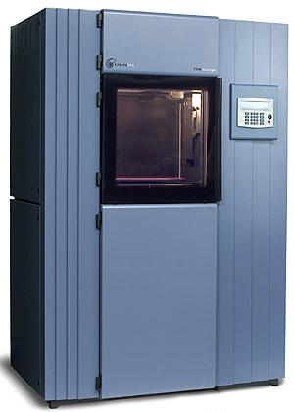

The FDM machine is one of the most popular 3D printers available. Basically, you can just send the SolidWorks file to the machine and it will directly receive the print design. By inserting the ABS material inside the machine it automatically starts building the required 3D shape in a specific time, depending on the size of the prototype (Hiemenz, 2012).

The first prototype was somehow big in size compared to the parts that were going to fit in. A lot of ideas were explored to modify the enclosure (see appendix 7.4) such as; making the columns which holds the PCB board and IOIO board taller, adding a slot for the battery charger, replacing the big slot of the SD card with a smaller one, making the slot of the ventilation smaller, removing the hole which was for the wires, making a sliding cover and making the walls thinner.

When we printed the second draft; it turned out nice and great except for the sliding cover which was not going all the way through the end. Once again a lot of research was done to figure out the right way to build the cover. Finally, after the final touches and editing the new design was made as shown below:

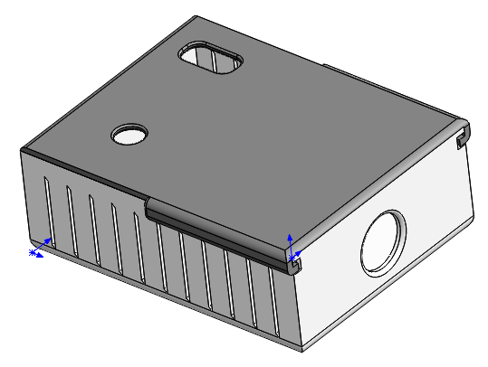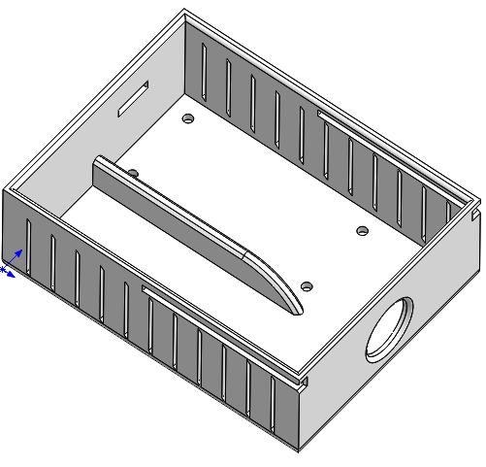

A unique prototype was printed to hold all the components together without any problems (Appendix 7.4).

**4.2 Design Tasks for each Member**

In the first week the class was divided into three teams. In the second class some students changed their group based on their request. We lost a group member in the process and were compensated with a new member who turned out to be a great asset to the team. Everyone was listening to each other respectfully when presenting ideas or giving suggestions. Our group had a common goal where everyone one was working towards achieving it. Although everyone had a design effort undertaken to meet the objectives of the project, each of us was trying to contribute in every aspect of the project.

Everyone in the group contributed to the following; project definition, researching for the IOIO and sensors, ordering the parts, installing and testing the sensors, engineering analysis, examining the first prototype, reviewing and troubleshooting, presentations, project report and documentations.

Moreover, Jessica took care of the initial sketches of the prototype as well taking care of the assembly documentation. Everyone one did the group ethics assignment. Also, Ryan did a great job in searching for the required battery and charger. He also wrote and organized the bill of materials in an arranged manner.

Not only that, both Adam and Saksham have done a lot of research about the storage. They also spent most of the time in writing the Java code for the sensors. They worked hard in writing the code as they made a lot of changes and debugging to build an effective program.

Furthermore, Bader put a lot of time and effort into designing and producing the enclosure. He developed three different completed prototypes and developed several other sketches and designs. Each prototype required him to research, sketch, design, and print a new enclosure and eventually resulted in a working enclosure that met our design specifications.

**4.3 Test Results and Conclusions**

Throughout the semester we have had to constantly test different elements of our project. We began by testing all of our electrical components with a multimeter to ensure they were working properly before we constructed our circuits.

For both the temperature and humidity sensors we tested them before and after we installed them to make sure they functioned properly. Before we installed them we used a multimeter to confirm that they were functioning by making sure there was a voltage reading across the sensor. After the sensors were installed we plugged the output into an equation to determine the temperature and humidity readings and compared these to the actual temperature and humidity readings to ensure they were correct.

The coding procedure was fairly simple. It involved initializing a pin for each to read the voltage. The temperature sensor reads in Celsius so we had to convert that to Fahrenheit. The humidity sensor uses a formula along with the temperature. So when we got that all written we tested to make sure it was working correctly.

The GPS was simple to connect to the circuit. While we were glad that GPS was working we had another problem to solve. The GPS was throwing out some random numbers that did not look like the map coordinates we were looking for. After spending some time on it to figure out what the problem really was we realized that each string of information that was concatenated in the GPS output had to be split into individual parameters and parsed. This way we could get our coordinates and other variables that defines useful GPS data. We were then able to figure out a way of plugging those coordinates into a map API and get the physical address for the GPS coordinates.

The Bluetooth was working intermittently in the beginning and we were not exactly sure why one Bluetooth unit would work and the other would not. After some testing, we separated out the working Bluetooth modules from the faulty ones. We never encountered any problems after using the ones that were separated from the faulty units.

We tested our enclosure for a few key requirements. One thing that needed to be tested was the size of the container. We tested this by installing all of the components to make sure they all fit. We also had to make sure the tolerances for the lid and container were within limits, this was tested simply by installing and removing the lid several times in doing this we also could determine if the slots where the lid fit were durable enough to withstand removing and reinstalling the lid.

As for the gas sensors we developed tests for both gas sensors, but only ended up being able to test the Nitrogen dioxide sensor. In order to test the gasses we had to build an airtight chamber to control the flow of gasses over the sensors. We obtained an airtight glad container, drilled two holes on opposite ends of the container and ran ¼” tubing out of both holes to allow for air to be connected and flow continuously over the sensors. In order to test the Nitrogen dioxide sensors we had to create Nitrogen dioxide by combining copper and nitric acid. We placed our device into the airtight chamber and connected a flask containing a small amount of copper shavings to a hose and an airline in order to allow the gasses to disperse faster. We used a syringe to combine the Nitric acid with the copper shavings by adding one drop at a time in order to produce small enough quantities of gas so as not to saturate the sensor. We have only obtained qualitative data from this test so far, but we believe in the future that we could determine the exact amount of gas the sensor is exposed to and make sure the sensors are calibrated correctly.

The test we created for the Ozone sensor was very similar to the test for the Nitrogen dioxide. We will use the same airtight chamber and other equipment to perform the quantitative testing. In order to produce the Ozone gas we will use oxygen and an electric spark in a flask and use the same technique of running air through the hoses to move the gas across the sensor. As with the Nitrogen dioxide this test will only be qualitative not quantitative, but will still be a valuable test in determining that the sensor does indeed work. The testing code involved reading the voltage of two pins and taking the difference. This gave us the millivolt equivalent of the sensors reading in PPM (parts per million).

The dust sensor has been tested for functionality, but not for accuracy yet. We exposed the sensor to a dusty environment and it registered a change, but we are unsure of the accuracy/calibration at this point in time. We will need to do more thorough testing in the future.

In the future we will need to do more extensive testing on several of our sensors. Our temperature and humidity sensors are completely functional and give correct outputs. The Nitrogen Dioxide, Ozone and dust/smoke sensors still need qualitative testing and further calibration to generate accurate readings.

**4.4 Final System Considerations**

There are some changes that still need to be made before the final design is completed. Continued work will be done to complete this project. The sensors will be further calibrated and additional sensors may be added as needed. We will also need to get the memory storage operational and easy to use. A charger will need to be researched that will work effectively to charge the battery of the device. Along with that a full power analysis and battery life analysis will need to be done. Also a more ergonomic enclosure will be made to allow patients to more easily transport the device.

**5. CONCLUSIONS AND SUMMARY**

In conclusion we ended up producing a functional Air quality monitor for asthma patients. Although not all of our sensors in this product are calibrated, it still currently gives a general idea of gas levels in a certain area allowing asthma patients to more accurately determine dangerous areas. Our recommendation for the product is that we should add a few more sensors, such as CO2, to make this product as useful as possible and we should also make it more compact so it can be easily carried. We think this product will be very useful and drastically improve asthma patient’s quality of life by allowing them to continually track their environmental factors and limit their exposure to hazardous elements. The future for this device is very good and we believe it will positively impact people’s lives and prove to be a useful and successful product in the medical device industry.

**6. REFERENCES (OR BIBLIOGRAPHY)**

* World Health Organization. (2010). Medical devices. Retrieved 12/15/2013, from <http://www.who.int/mediacentre/factsheets/fs346/en/index.html>

* Federal Communications Commission. (2010). Frequently asked questions. Retrieved 12/06/2013, from <http://www.bureauveritas.com/wps/wcm/connect/31b53f004edb713e8d5fcd600bbc220b/FCC_Frequently_Asked_Questions_Aug10.pdf?MOD=AJPERES>
* Oocities Organization. (2009). Why use SolidWorks. Retrieved 12/08/2013, from

<http://www.oocities.org/wpsmoke/solidworkswhy.html>

* Hiemenz, Joe. (2012). Excerpt 2: 3D printing with FDM Technology: How it Works. Retrieved 12/03/2013, from

<http://blog.stratasys.com/2012/09/08/excerpt-2-3d-printing-with-fdm-technology-how-it-works/>

* OSHA(2013). Limits for Air Contaminants. retrieved Oct. 2013. from <https://www.osha.gov/pls/oshaweb/owadisp.show_document?p_table=standards&p_id=9992>

**7. APPENDICES:**

**Appendix 7.1 Bill of Materials (BOM)**

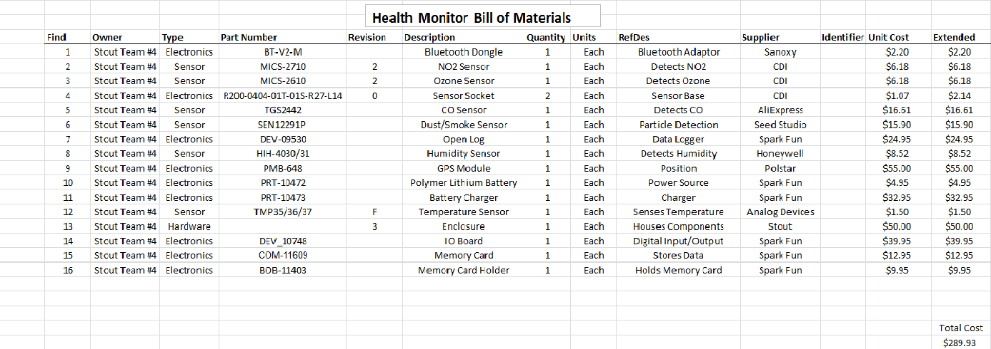

**Appendix 7.2 System Cost Summary**

Cost for each individual unit.

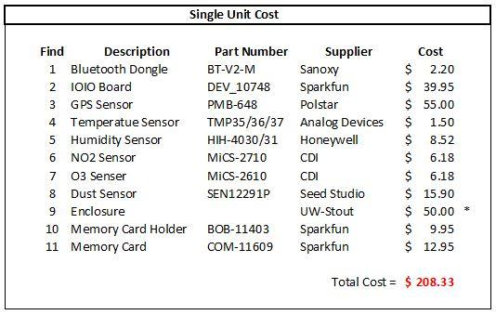

**Appendix 7.3 Data Sheets and Vendor Specifications**

|  |  |
| --- | --- |
| PART | DATASHEET LINK |
| GPS Sensor | <http://www.parallax.com/sites/default/files/downloads/PMB-648-v0.1.pdf> |
| Temperature Sensor | <http://www.analog.com/static/imported-files/data_sheets/TMP35_36_37.pdf> |
| Humidity Sensor | <https://www.sparkfun.com/datasheets/Sensors/Weather/SEN-09569-HIH-4030-datasheet.pdf> |
| Ozone Sensor | <http://airqualityegg.wikispaces.com/file/view/mics-2610+-+O3.pdf> |
| NO2 Sensor | <http://www.cdiweb.com/datasheets/e2v/mics-2710.pdf> |
| Dust Sensor | <http://www.seeedstudio.com/wiki/Grove_-_Dust_sensor> |
| Rechargeable Battery | <http://dlnmh9ip6v2uc.cloudfront.net/datasheets/Prototyping/Lithium%20Ion%20Battery%20MSDS.pdf> |

**GPS Sensor**

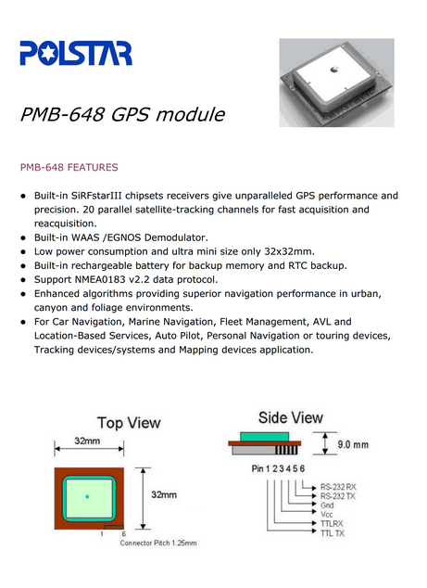

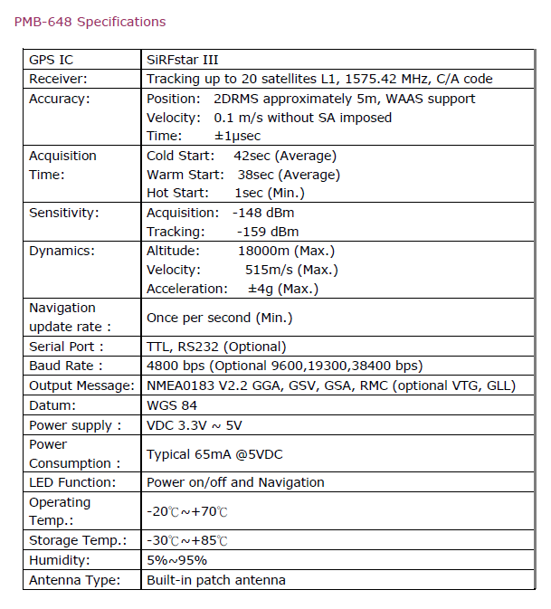

**NO2 Sensor**

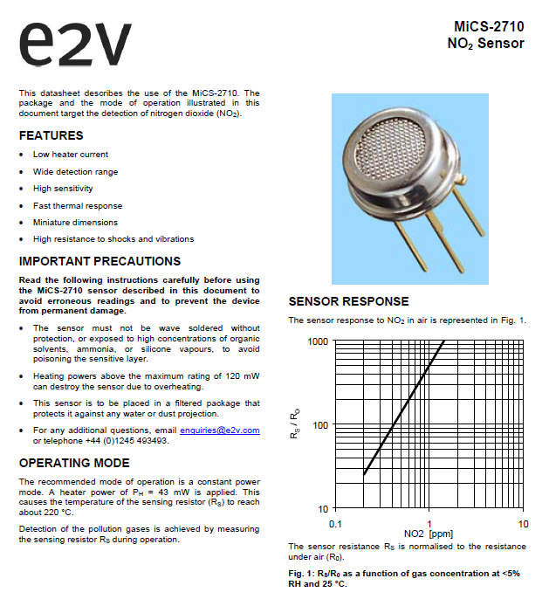

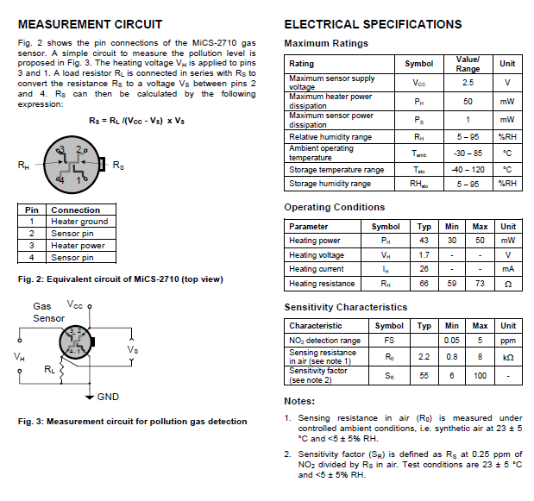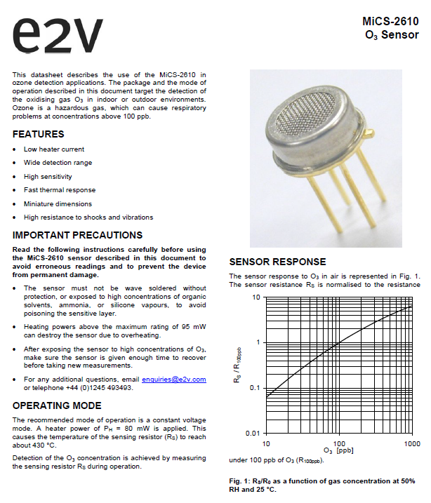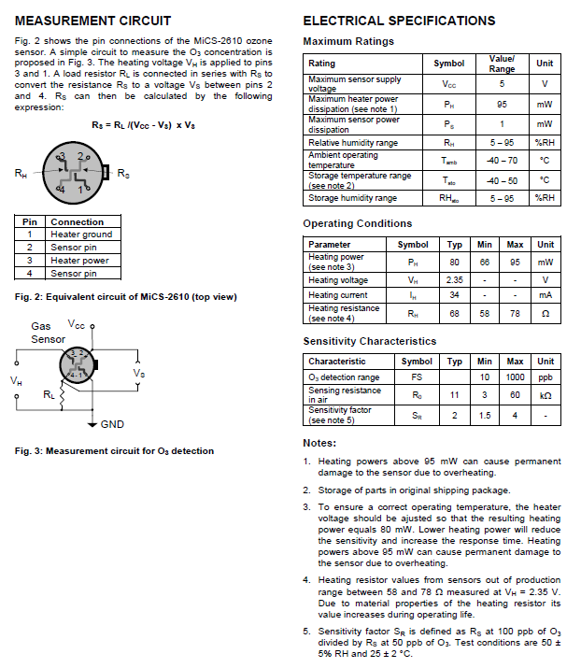

**Temperature Sensor**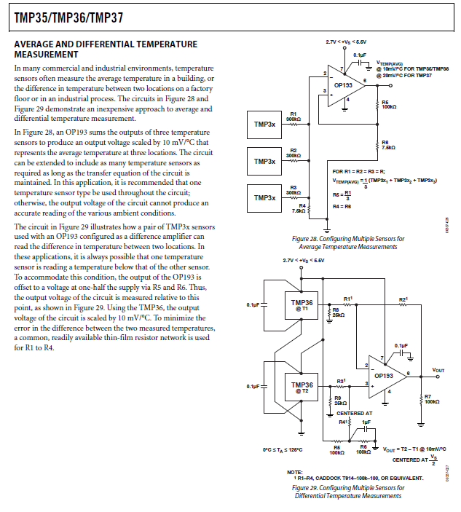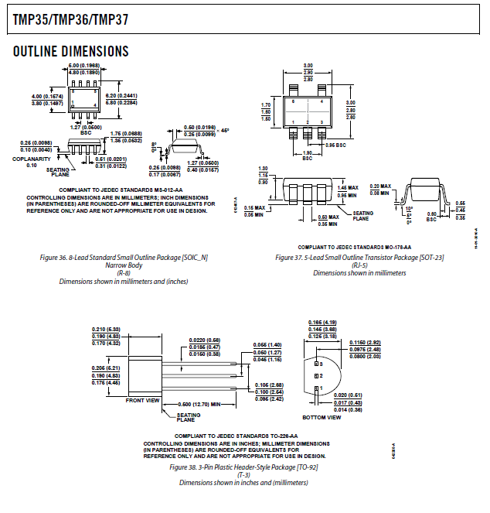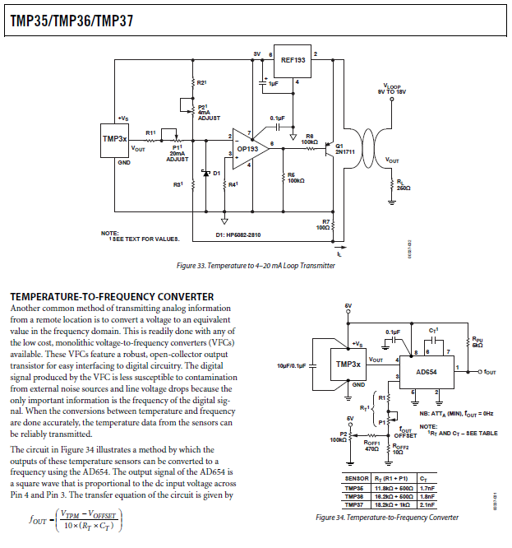

**Dust Sensor**

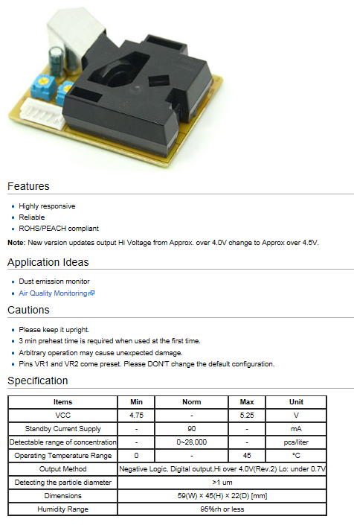

**Humidity Sensor**

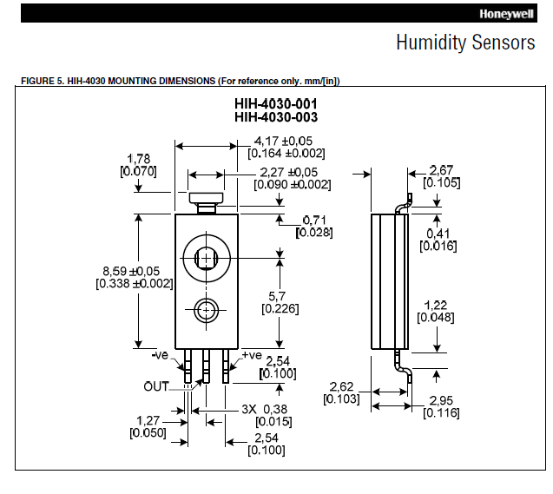

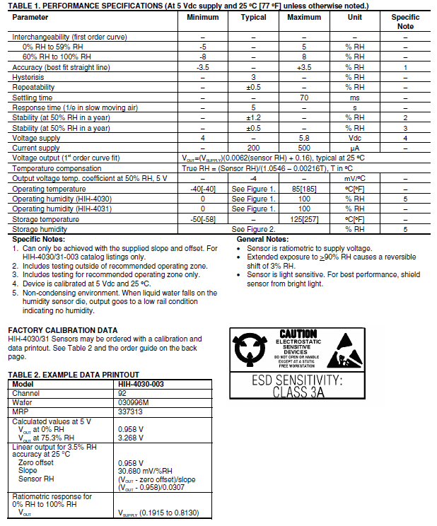

**Battery**

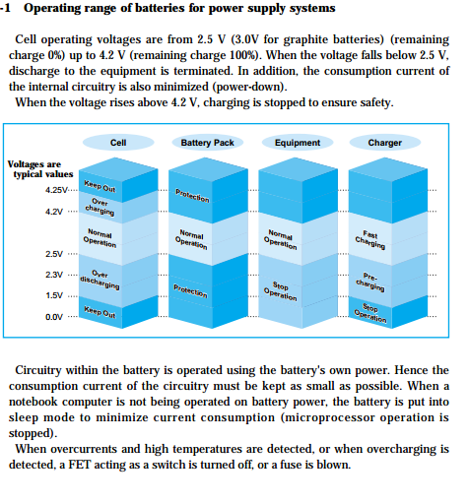

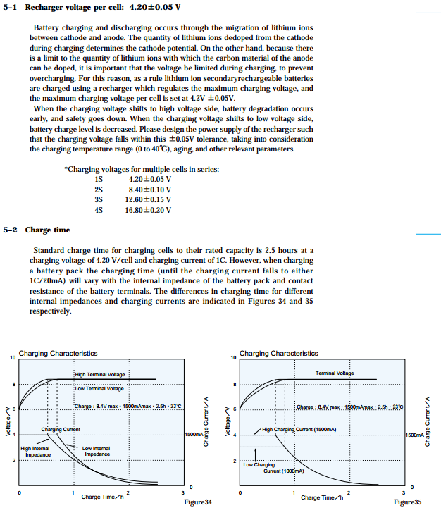

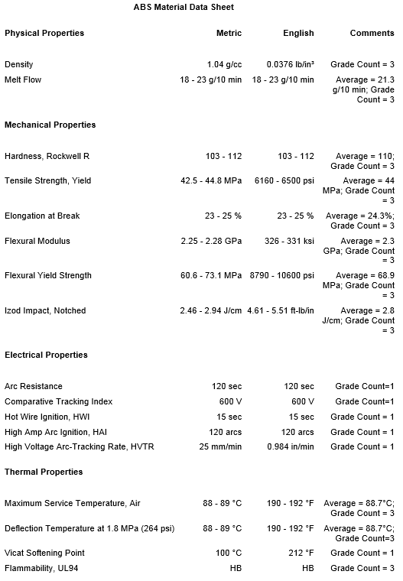

**Appendix 7.4 Physical Description of Product**

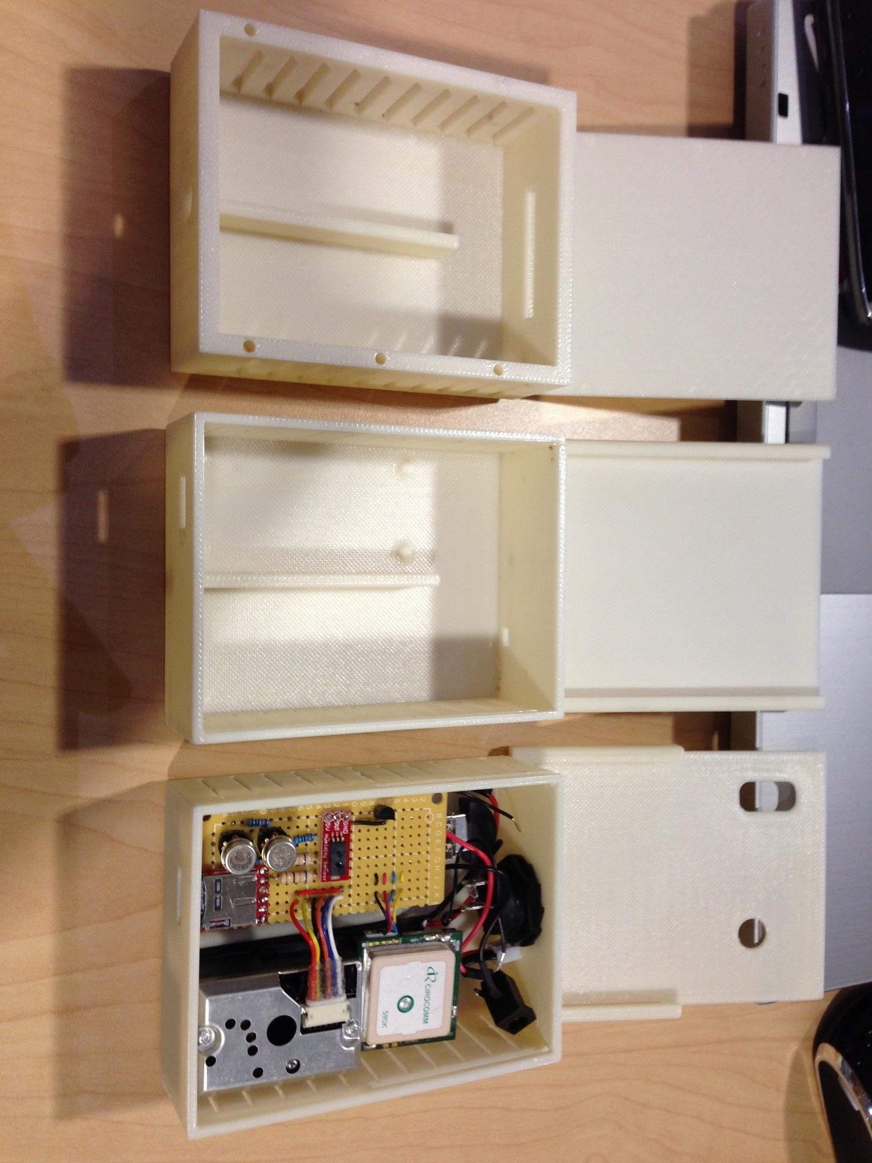

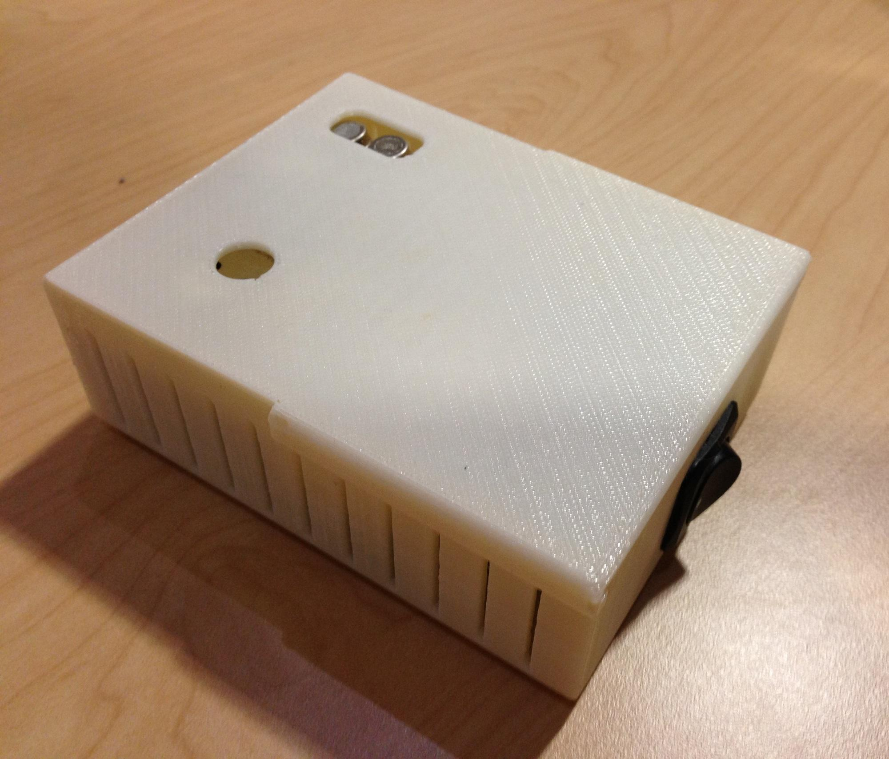

**Appendix 7.5 Testing**

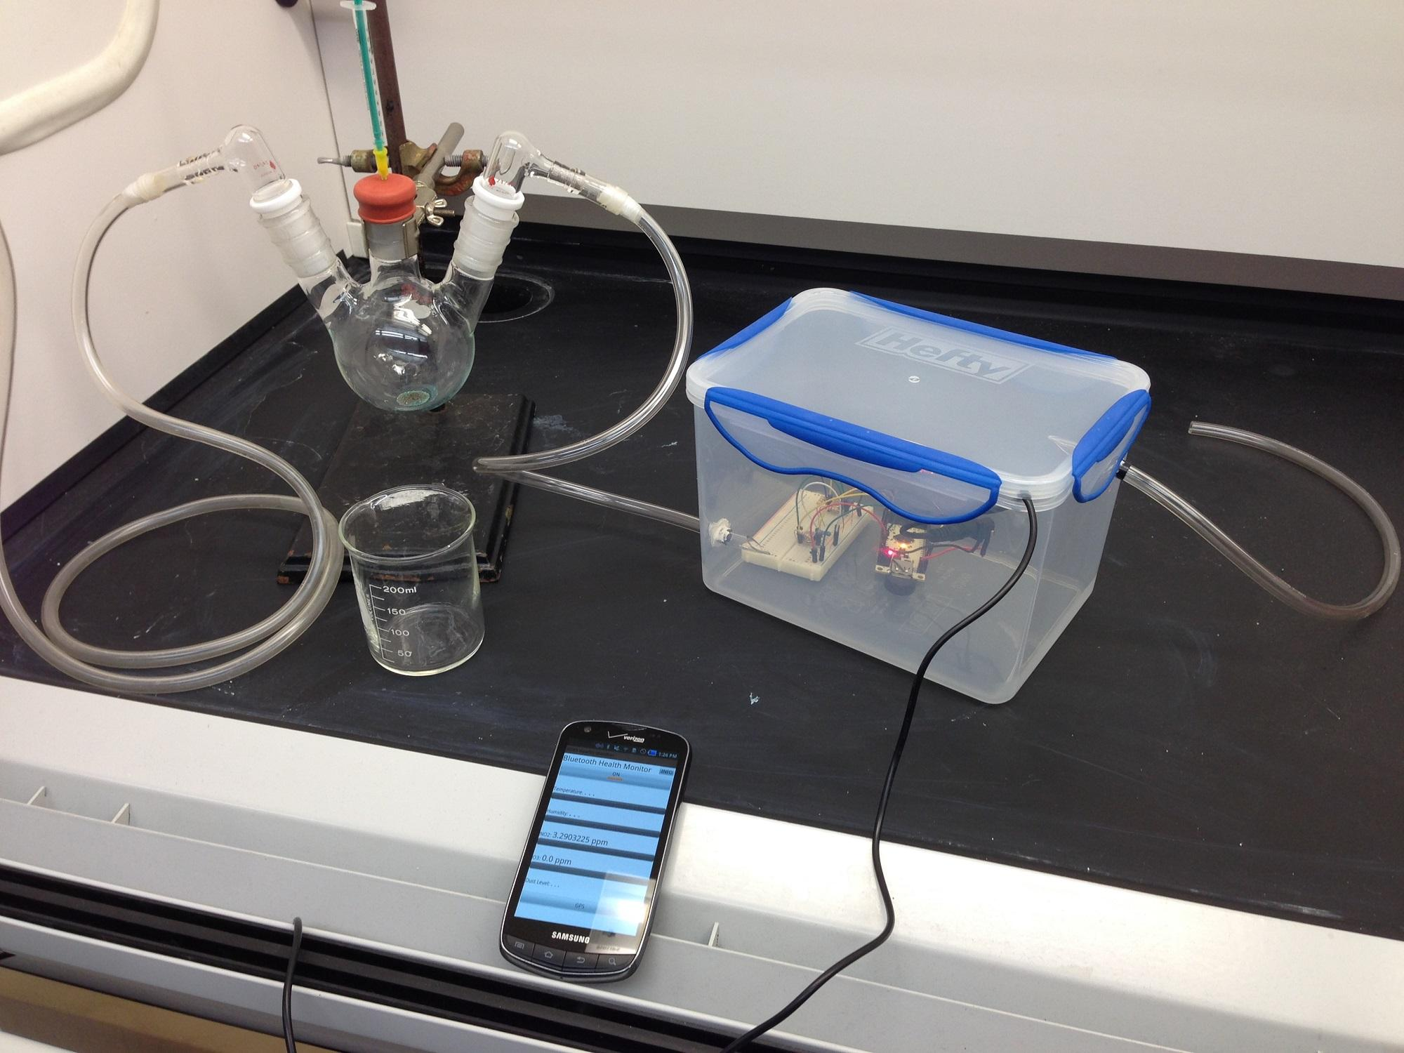

**Appendix 7.6 Calculations**

